Screenshot for spotify-this-song results:

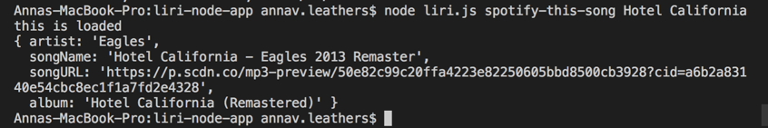

Screenshot for concert-this results:

